COMSATS University, IslamabadData Communications and Computer NetworksBS(CS)-5BLAB Mid Term TaskDue Date: ViVa 24th November 2021 Total Marks: 15  
---------------------------------------------------------------------------------------------------  
Important Note: Copying a Project or a Part, from any source would be considered as aserious offense that will results in Zero Marks.

1. The project will be GUI based C**hat Room** application built using TCP Sockets and Swing in Java.
2. TCP Server is responsible to enables multiple clients to communicate and interact with each other.
3. Server application can handle multiple client requests.
4. Clients can broadcast messages with each other, and specifically interact with fellow client application.
5. There must be Menu on Server side that enlists all the Clients attached to Server.
6. The Server may select any of the Clients or Broadcast the message to all the Clients connected.

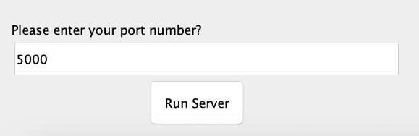

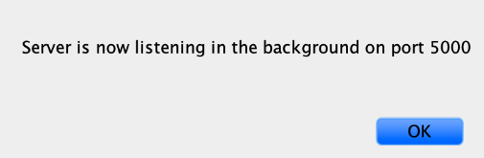

1. After all this we have a Viewing Area for Chat Box consist of Display Area, TextBox for writing message and Button to send Message.
2. Project Report must be submitted by all students individually at the time of VIVA.